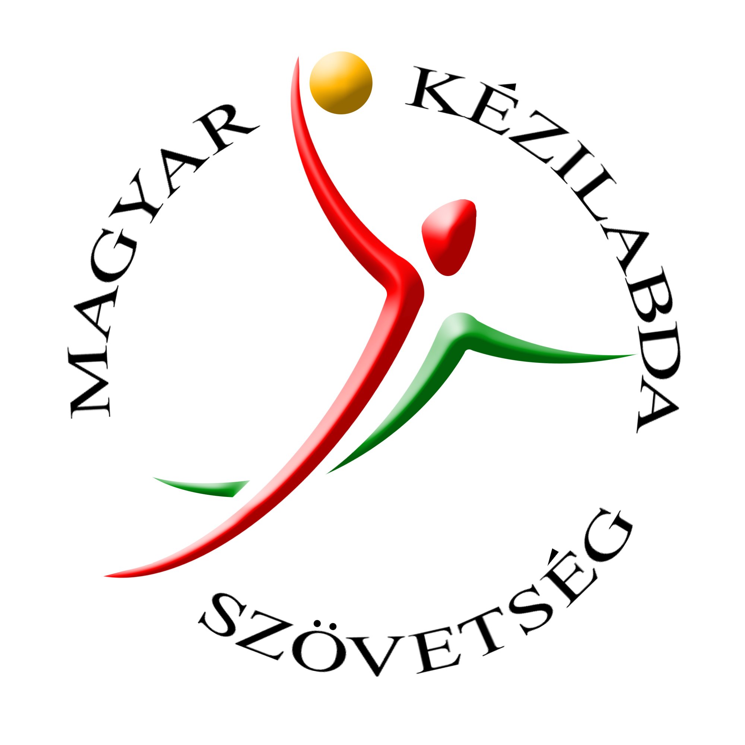
Attention: National Handball Federations

Subject: Annual Coaching Seminar, Hungary 2015

Dear Handball Friends,

The International Coaching Education Centre of the Hungarian Handball Federation (HHF) invites you to its Annual International Coaching Seminar.

Venue: Balatonfüred, Hungary (situated at Lake Balaton, approx.120 km from Budapest Airport, 195 km from Vienna Airport and 170 km from Bratislava Airport)

Dates: 5 - 7 of June, 2015

Accommodation and Food: Hotel Marina **** (all inclusive)

Location of Practical and Theoretical Lectures: Balatonfüred Sports Hall (within walking distance of the hotel)

Expenses: the participation fee of 250 Euros includes full board and accommodation at Hotel Marina (2 nights / 3 days in double rooms*), seminar fee, course material via internet and final certificate (* = single bedroom for extra fee is possible)

Payment: should be made to: HHF Bank account (see details on the Registration Form)

Main theme of the course: “Developing individual skills as basic conditions for high quality teamwork”

Lecturers: apart from the Hungarian experts in coaching and sport science, well known coaches like Branislav Pokrajac (SRB) and Juan Carlos Pastor (ESP) are also included on the list of lecturers.

Course Language: Hungarian (where there is a group of more then 10 persons speaking the same language, translation will be possible)

Additional information is available at the HHF office by contacting Zoltán Marczinka (Tel.: 460-6820, e-mail: marczinkaz@keziszovetseg.hu) and registration can be made through Imola Hikáde (hikadei@keziszovetseg.hu) until May 22, 2015.

I am looking forward to meeting you at Balatonfüred,

Best regards,
Zoltán Marczinka

Director
International Coaching Education Centre
Hungarian Handball Federation

Note: please find the Seminar Schedule and the Registration Form attached

