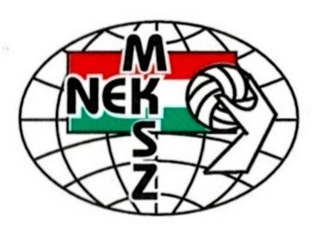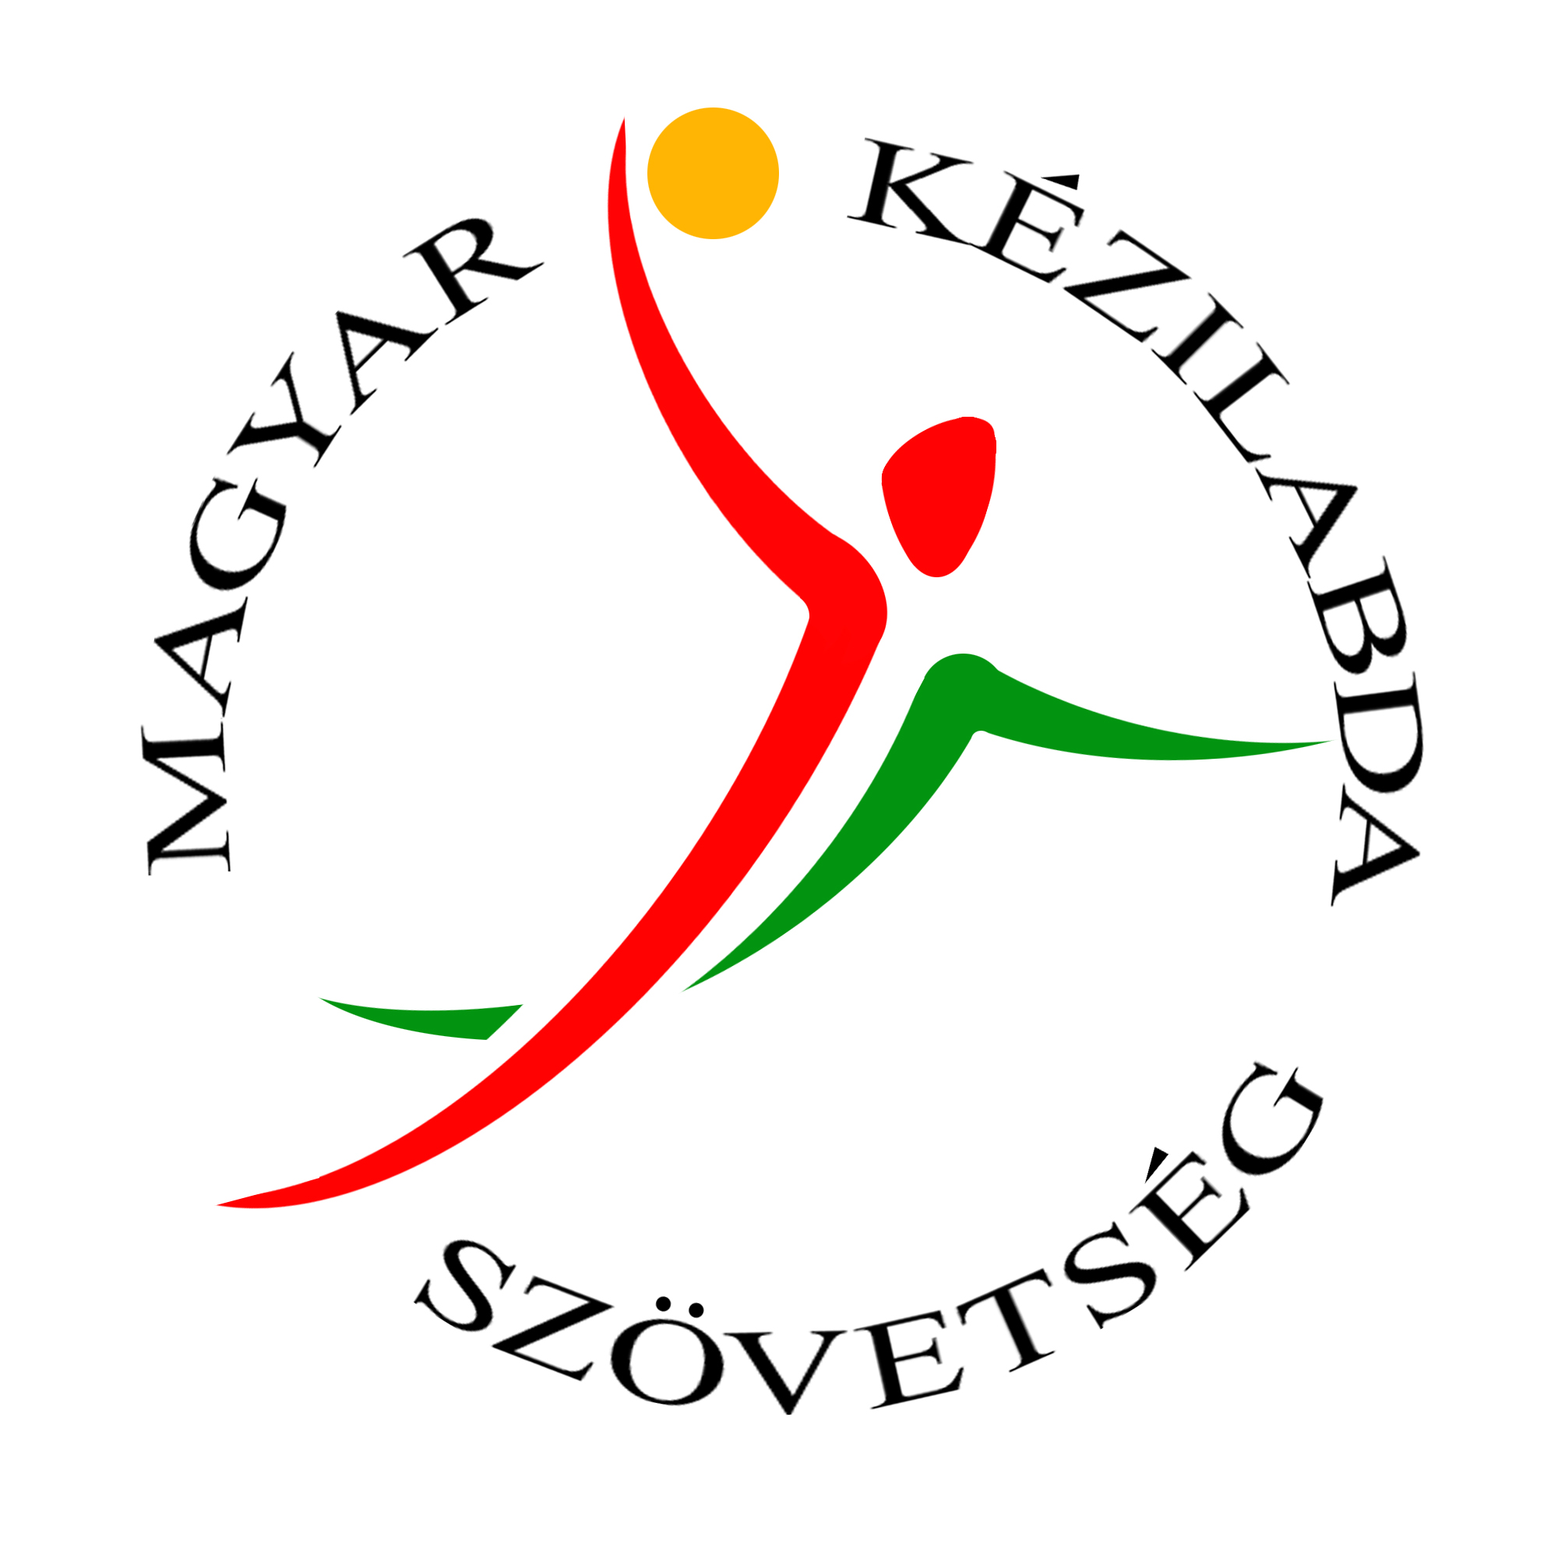
International Coaching Education Centre
Hungarian Handball Federation

H-1146 BUDAPEST, Istvánmezei u. 1-3
Tel: +36 1 460 6820 web: www.handballnet.hu
Registration Form
Annual Coaching Seminar - HUN 2015
Name:

E-mail:

Telephone:

Address:

1. Accommodation:
I would like a single room a double room accommodation (please mark).
If you would like a double room please name the person you would like to share with.
Name:
Note: extra fee for single room is 15 Euros / night / person
2. Payment:
Name of the Bank: Erste Bank Hungary Zrt
Address: 1138 Budapest – Népfürdő utca 24-26
Swift code: GIBAHUHB
Iban: HU32 1160 0006 0000 0000 6179 3882
Name of the Federation: Magyar Kézilabda Szövetség
Address: 1146 Budapest, Istvánmezei út 1-3.

3. Invoice details:

Name:
Address:
EU Tax number (clubs, companies):

Zoltán Marczinka ICEC Director Imola Hikade ICEC Secretary e-mail: marczinkaz@keziszovetseg.hu e-mail: hikadei@keziszovetseg.hu

